# CST2355 – Database Systems Group Lab Assignment 1

## Topic: Usage instructions of Inventory Management System for skinxbeautyph

1. Open the Access file by double clicking it.
2. The Main Menu will pop out. Forms color-coded **blue**. Reports are color-coded **green**. The main purpose of the report is to track the Stock on Hand of the items and the product hierarchy.

1. Form Usage and Purpose (the word manage here is used to refer to add, edit, update, delete data)
   1. Suppliers form – manage data of suppliers of products.
   2. Brands form – manage data of product’s brand.
   3. Products form - manage data of products. The Products form contains the subforums to determine if the product’s subtype is, namely soap, cream or sunblock.
   4. Employees form - manage data of employees.
   5. Shops form - manage data of the shops where the products were sold.
   6. Stock in form - manage stock in transactions of the products.
   7. Stock out form - manage stock out transactions of the products.
      1. Sample usage of the form:
         1. Click the desired form.
         2. You can input/choose the data from the fields, example see **blue** checks (see screenshot below)
         3. You can add, save, delete or search records, example see **red-orange** checks (see screenshot below)

1. Report Usage and Purpose
   1. Click on the desired report.

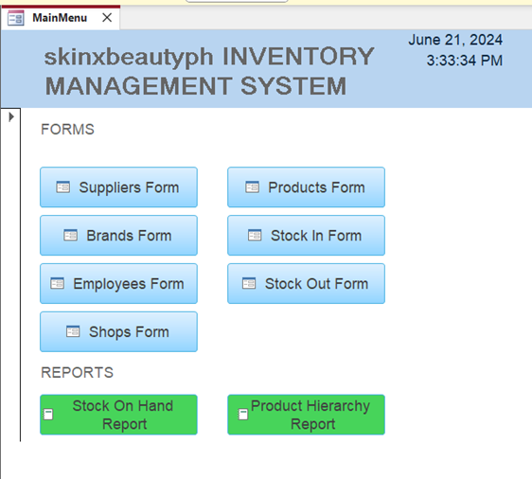

* 1. Report will launch and show you the desired report.

* 1. Report Purpose
     1. Stock On Hand Report – this report shows the user the available products on hand in the inventory for sale.
     2. Product hierarchy Report – this report shows the user hierarchy of which supplier supplies which brands and which products are related to which brand.